**What Do We Believe?**

Our statement of faith can be succinctly summarized in the Constantinopolitan-Nicene Creed (325-381 AD):

*We believe in one God, the Father Almighty, Maker of heaven and earth, and of all things visible and invisible;*

*And in one Lord Jesus Christ, the Son of God, the Only-begotten, Begotten of the Father before all ages, Light of Light, True God of True God, Begotten, not made; of one essence with the Father; by whom all things were made:*

*Who for us men and for our salvation came down from heaven, and was incarnate of the Holy Spirit and the Virgin Mary, and was made man;*

*And was crucified also for us under Pontius Pilate, and suffered and was buried;*

*And the third day He rose again, according to the Scriptures;*

*And ascended into heaven, and sits at the right hand of the Father;*

*And He shall come again with glory to judge the living and the dead, Whose kingdom shall have no end.*

*And we believe in the Holy Spirit, the Lord, and Giver of Life, Who proceeds from the Father, Who with the Father and the Son together is worshipped and glorified, Who spoke by the Prophets;*

*And we believe in one, holy, catholic, and apostolic Church.*

*We acknowledge one Baptism for the remission of sins.*

*We look for the Resurrection of the dead,*

*And the Life of the age to come. Amen.*

**Weekly Worship Schedule**

**Sundays:** Divine Liturgy (DL) 10:30 AM

**Tuesdays:** Confession 11:00 AM  
Sixth Hour 12:00 Noon

**Wednesdays:** Confession 11:00 AM  
Divine Liturgy 12:00 Noon

**Holy Days:** Confessions 11:00 AM  
Divine Liturgy 12:00 Noon  
(See also website/bulletins)

**Contact Us**

Address: 2336 Brownsville Road Pittsburgh, PA 15210

Office Phone: (412)-881-8344  
Fax: (412)-884-7504

Email:  stpiusxchurch@verizon.net

Website: http://stpiusbyz.org/ 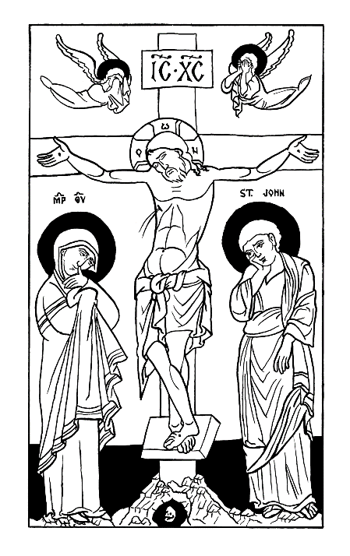

***St. Pius X Byzantine Catholic Church***

**Who We Are**

We are the praying community of Pope St. Pius X, Patriarch of the West, Byzantine Catholic Church. Our Parish serves the spiritual needs of Byzantine Catholic Christians in the greater Central South Hills area of Pittsburgh. We pray for the continued growth of peace and flourishing of all our neighbors and neighborhood as a whole and welcome all interested in coming to learn more about our faith.

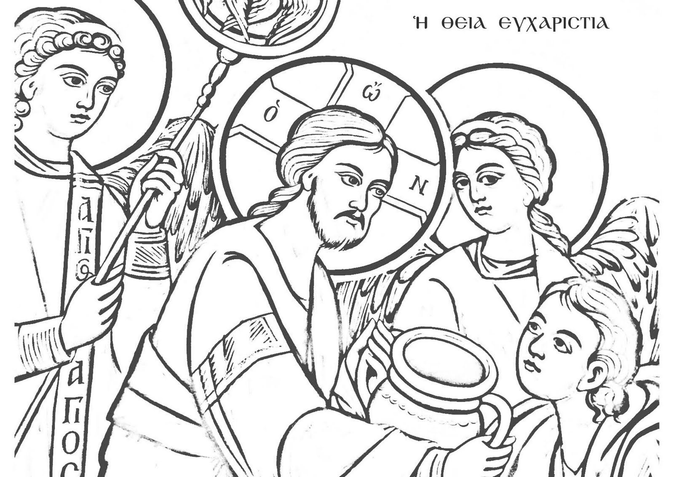

**Brief Parish History**

The 19th century saw the mass migration of many peoples to the USA. This included large communities from the Austro-Hungarian Empire of Carpatho-Rusyn origins, territorially from parts of modern-day Eastern Slovakia, Western Ukraine, Northern Romania, Croatia, and Hungary. These people, like many other immigrants of that time, came to work in the steel factories and coal mines of Southwestern Pennsylvania. They founded many communities centered around their unique religious beliefs and spiritual expressions. Our parish community was founded in 1954.

**How We Worship**

Our worship is directed always and exclusively to the Holy Trinity: the Father, the Son, and the Holy Spirit. Public worship is predominantly centered around the Liturgy and 7 Sacraments, visible signs of the invisible workings of the graces of God. Our principal service is the Divine Liturgy of St. John Chrysostom, where we celebrate the Eucharistic Sacrifice instituted by Christ Himself at the Last Supper. Through reading Sacred Scripture, recitations of ancient prayers, and through our tradition of sacred chant, we join ourselves in the totality of our senses to the Divine.

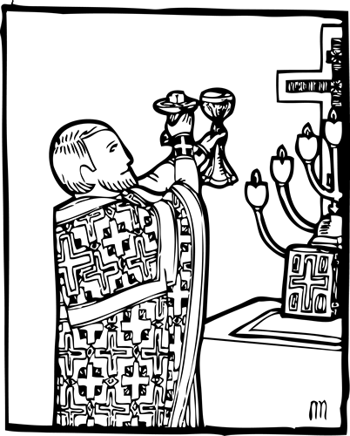

In our private prayer life, we are called by St. Paul the Apostle to “pray without ceasing,” which we do primarily through the Jesus Prayer: “Lord Jesus Christ, Son of the Living God, Have Mercy on Me a Sinner.”

**What Is Byzantine Catholicism?**

The Byzantine Catholic Church one of the 24 particular communities that form the Communion of Catholic Churches. While the Roman Catholic Church is by far the single largest of these communities, there are 23 “Eastern” Catholic Churches, each with their own unique history, liturgical practices, spirituality, and theological perspective. The Byzantine Catholic Church has its roots in Eastern Orthodox Slavonic Christianity, dating back to when Christianity was first brought to the region by Ss. Cyril and Methodius and Ss. Volodymyr and Olha between the 9th to early 11th centuries AD. Our Communion with the Universal Catholic Church was re-established in 1646 at the Union of Uzhorod. We recognize the Popes of Rome as the rightful heirs to the apostolic throne of St. Peter the Prince of the Apostles.

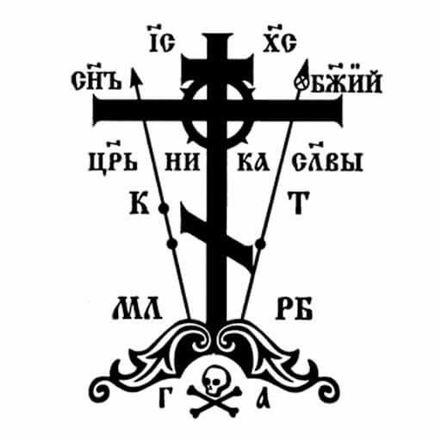

**Icons, the Saints, and the Theotokos**

One of the most characteristic features of Byzantine Christianity is our emphasis on the use of Icons, holy Images. We believe that Christ is the Image of the Father and that it is fitting to worship using sacred images as aides, not as idols. The Icon Screen, perhaps the most distinctive piece of our worship tradition, is an evolution of the veil from the Temple of Solomon which divided the Holy of Holies from the Holy Place.  
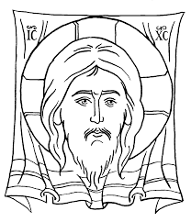

We believe also in the communion of saints, those who have lived lives pleasing to God and we turn to them to help us emulate the life of Christ. Among the saints, there is none we revere (not worship) more than the mother of Christ, Mary, who we call the “Theotokos” since she bore God the Word who took on flesh in her womb.

